5/26/2022

Data Analytics Interim Project Proposal

**Proposed by:**

Lija Joju

Shawanda Asbury

Revathy Paramasivan

Halima Miah

Farha Hai

Danella Herrera

|  |  |
| --- | --- |
| **Table of Contents** |  |
| Table of Contents ………………………………………………………... Page 1 | |
| Overview…………………………………………………………………... Page 2 | |
| Objectives and Steps…………………………………………………...... Page 3 | |
| Question 1…………………………………………………………………. Page 3 | |
| Question 2……………………………………………………………….... Page 4 | |
| Question 3…………………………………………………………………. Page 5 | |
| Question 4…………………………………………………………………. Page 6 | |
| Question 5…………………………………………………………………. Page 7 | |
| Question 6……………………………………………………….………... Page 8 | |

**Data Analytics Interim Project Proposal**

**Overview:**

The AdventureWorks demo database serves as a great platform to practice SQL and data analytics skills. With this project, our group will be given the opportunity to boast the SQL, Excel, and data analytics skills that we have learned thus far in the Generation Data Analytics program.

|  |  |
| --- | --- |
| Proposed by: | Lija Joju  Shawanda Asbury  Revathy Paramasivan  Halima MIah  Farha Hai  Danella Herrera |
| Timeframe: | **Completion by:** May 26, 2022, at 12:45 PM CST  **Presentation on:**  May 26, 2022 at 1:45 PM CST |

**Objectives and Steps**

With the use of specific data found in Adventure works we were tasked to answer the following questions:

1. What is the regional sales in the best performing country?

* For this step, our group broke down the question into two parts. First, we wanted to join and filter the Sales Territory and Country Region tables to see what the top countries were regarding sales. Once this was narrowed down, we began to investigate the different regions. From the resulting table, we analysed the information by the sales year to date and sales from the previous year. In the end, the results were: best performing country was the USA, and the region was Southwest.

**Query:**

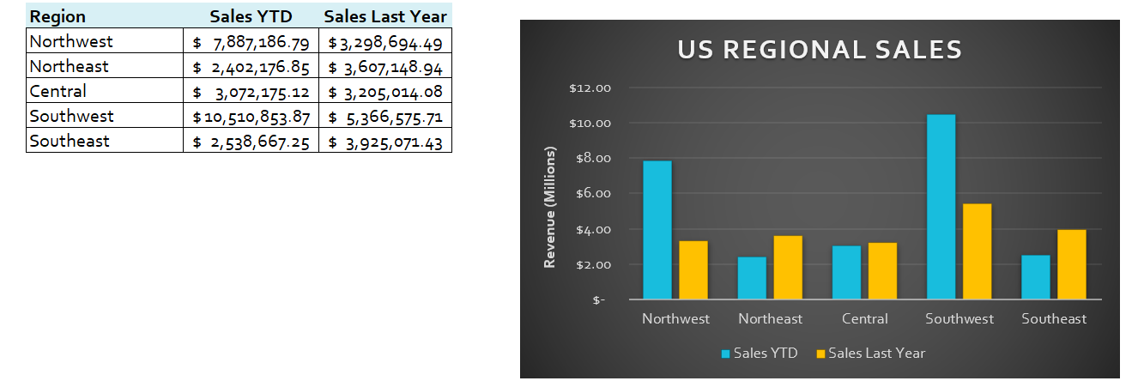

**Visualization:**

1. Identify the three most important cities. Show the breakdown of top-level product categories against city.

* In this question, we needed to identify the top three cities showing the product and sales. We had to use multiple tables such as (Product, Product Subcategory, Sales Order Header, Address, and Sales Order Detail) and used inner joins and subqueries. First, we focused on joined the appropriate tables. After joining the tables, we wanted to filter the data to see what city generated the highest sales. Also, it was crucial to see what product was associated with these sales. From the results, Toronto was the top city followed by Seattle and London.

**Query:**

**Visualization:** 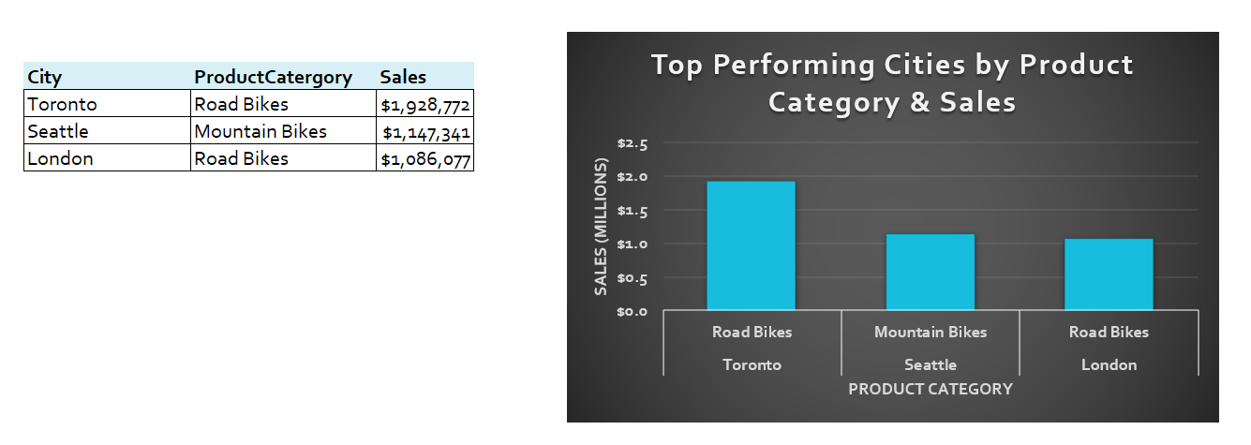

1. What is the relationship between Country and Revenue?

* To identify a relationship between Country and Revenue, our group decided to look at the Sales Territory and Country Region tables to find a connection between a country, current year revenue, and last year revenue. The data joined table was filtered to show the highest revenue among the countries. The percent change was calculated to see any growth. Additionally, to visualize the possible change, we created a chart to analyse any growth or decrease in revenue between the last year and current year. From the data, the USA had the greatest increase in growth, following by Great Britain. Also, from the chart we can see Germany and Canada has the least revenue growth.

**Query:**

**Visualization:**

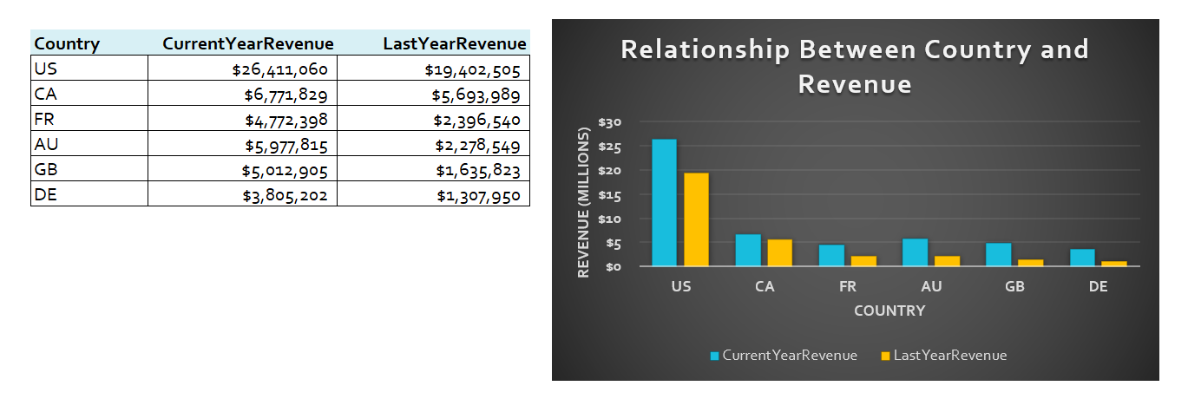

1. What is the relationship between sick leave and Job Title?

* To identify a relationship between sick leave and job title, the employee table and employee department view were studied. Our group looked at the Job Title, Sick Leave Hours, Organizational Level, and Group Name fields to see the connection between sick leave and job title. The data was filtered by the group name, to see if there was a specific relationship between group name and sick leave taken.
* Below are a few things that was noticed:
  + Stockers seem to be too busy to take sick days, they have more sick leave hours available.
  + The higher the position the more sick leave are taken.
  + The individuals in the lower organizational level (4) seem to have a penalty when taking sick leaves such as taking sick leave can affect their chance at a promotion.
* Additionally, it was noticed that in some departments, as a suggestion, more individuals should be hired to help people take sick leave.

**Query:**

**Visualization:**

1. What is the relationship between store trading duration and revenue?

* To identify the relationship between store trading duration and revenue, the store with demographics view was analysed. Our group wanted to see what the annual average of revenue for each store since the opening year was. From the visualization we can see that the newer the store the higher the revenue.

**Query:**

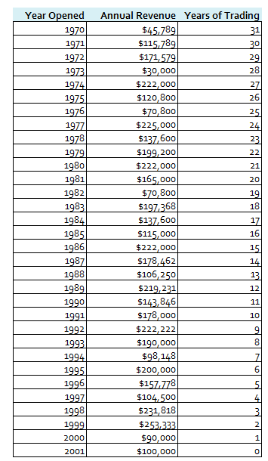**Visualization:**

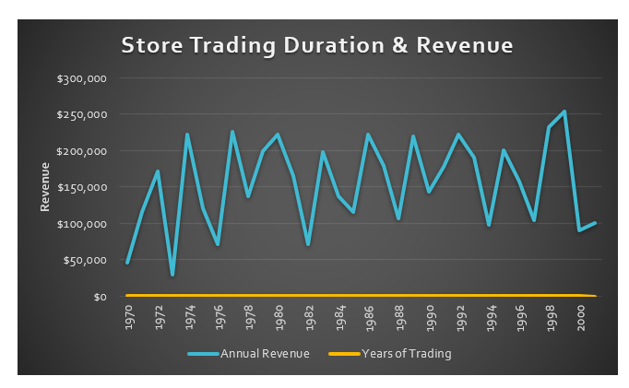

1. What is the relationship between the size of the stores, number of employees and revenue?

* To identify relationship between the size of the stores, number of employees and revenue, our group looked at the view named Store with Demographics. Specially we looked at the fields Number Employees, Square Feet, and Annual Revenue. Large stores require more overhead cost (such as rent, employee cost).

**Query:**

**Visualization:**

**. .**

**. .**

**. .**